- INTRODUCTION
Ground-based telescopes provide high light-gathering capability and improved spatial resolution with increasing aperture size. For a telescope of diameter D observing at wavelength λ, the diffraction-limited angular resolution is approximately

θ ≈ λ / D (radians)

For example, a 1 m telescope observing at 500 nm has a diffraction limit of about 100 milliarcseconds [1]. However, this theoretical resolution cannot generally be achieved because light travelling through the Earth's atmosphere experiences turbulence. Variations in the atmospheric refractive index distort the incoming optical wavefront, so that the image is spread over an angular size of approximately λ/r₀, where r₀ is the atmospheric coherence diameter, typically 2–20 cm at visible wavelengths. The resulting seeing-limited image is of the order of 0.5–1 arcsec, much larger than the diffraction limit [3], [7].

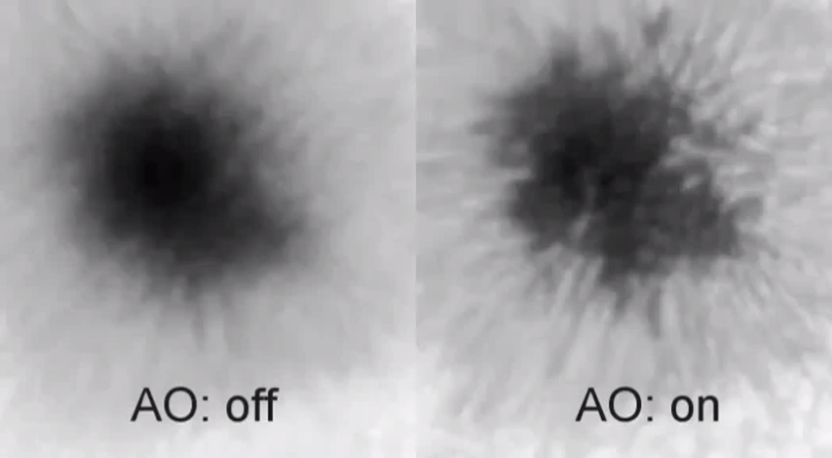
Figure 1.1: Sunspot observed without (left) and with (right) adaptive optics correction.

As illustrated in Figure 1.1, atmospheric turbulence blurs fine solar structure that becomes visible only once the wavefront distortion is corrected. The wavefront perturbation can be decomposed into a global tilt across the aperture and smaller corrugations on top of it. The global tilt causes the image to wander about its mean position at the focal plane, while the corrugations blur the image [1], [7].

Adaptive optics is used to reduce the effect of atmospheric turbulence. The basic concept of compensating for atmospheric seeing using an adaptive optical system was proposed by Babcock [2]. An adaptive optics system measures the wavefront distortion using a wavefront sensor, computes the required correction in a control system and applies it using a deformable mirror, as shown in Figure 1.2. Because the atmosphere changes on millisecond timescales, the correction must be updated at 200 Hz – 1 kHz [1].

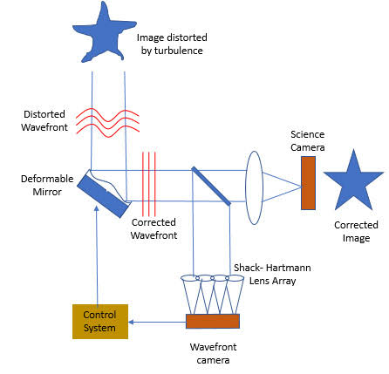
Figure 1.2: Closed-loop structure of an adaptive optics correction system.

Solar observations require particularly fast processing. Unlike night-time astronomy, there is no point source on the Sun that can be tracked; instead, short-exposure images of extended features such as granulation, sunspots or pores are cross-correlated with a reference image at kHz rates to find their relative shift [1]. In a large solar adaptive optics system, many sub-aperture images need to be processed within each millisecond. The proposed National Large Solar Telescope (NLST) considered in the SolarAccel work requires approximately 430–450 sub-aperture images [1], [14].

For this reason, dedicated hardware acceleration can be used to reduce the computational latency of image processing. SolarAccel investigates the use of FPGA hardware for accelerating two-dimensional cross-correlation of digital images.

The main objective is to investigate the latency and hardware requirements of FPGA-based image cross-correlation, to study how pipelining, fixed-point arithmetic and parallel processing affect the performance of the design, and to assess whether the approach can scale to an adaptive optics system of the size required by NLST.

- LITERATURE REVIEW
Adaptive optics was originally proposed as a method of compensating for atmospheric seeing in astronomical observations [2]. Fried developed a statistical description of wavefront distortion and showed that a large part of the perturbation introduced by the atmosphere is a linear tilt [3]. Roddier reviewed the effects of atmospheric turbulence on optical astronomy and described the seeing in terms of the atmospheric coherence diameter r₀ [7].

Shack–Hartmann wavefront sensors are commonly used to measure wavefront distortions. For solar observations, the images produced by the individual lenslets contain extended solar structures rather than point sources, so correlation-based image-shift detection is used to determine their displacement. Gu et al. recently demonstrated a compact embedded solar adaptive optics telescope that uses a 12 × 12 micro-lens Shack–Hartmann sensor with normalized cross-correlation and a 61-actuator deformable secondary mirror, maintaining a wavefront error of about λ/10 during on-sky observations [4].

FPGA-based image processing has also been investigated for computationally intensive operations such as image cross-correlation. Haji Rassouliha et al. implemented the complete cross-correlation flow on a Virtex-6 FPGA using the Xilinx System Generator flow, achieving a latency of 28.6 μs for 32 × 32 images at 250 MHz [5]. Li and Wyrwicz implemented a parallel 2D FFT on an FPGA for real-time MR image processing and reported a latency of 310 μs for 128 × 128 images at 80 MHz [6].

Phase correlation, introduced by Kuglin and Hines, estimates the shift between two images from their normalized cross-power spectrum and produces a sharp correlation peak [8]. Building on these concepts, SolarAccel investigates an FPGA-based architecture for two-dimensional cross-correlation specifically aimed at solar adaptive optics. The work uses FFT-based processing and evaluates different architectures involving pipelining, fixed-point arithmetic and parallel processing [1].

More recent work has extended FPGA acceleration to larger adaptive optics problems. Abo Rdan et al. showed that FPGAs can substantially accelerate high-order wavefront sensing and control algorithms for high-contrast exoplanet imaging instruments [9]. Yang et al. designed a ground-layer adaptive optics system for the 2.5 m wide-field and high-resolution solar telescope, showing that correction over a wide field is feasible but requires high-throughput real-time processing [10]. Phanindra et al. developed an FPGA-based fast data acquisition system for solar adaptive optics, addressing the camera-to-processor data path that precedes the correlation stage [11]. Table 2.1 summarizes the literature reviewed in this report.

Table 2.1: Summary of Literature Survey
Ref. | Authors and Year | Focus of Study | Key Findings
[1] | Das et al., 2024 | FPGA accelerator for 2D cross-correlation in solar adaptive optics on the ZCU104 platform | Latency of 137 μs (128 × 128) and 13.4 μs (32 × 32); about 11× faster than the initial serial design
[4] | Gu et al., 2025 | Embedded solar AO telescope using normalized cross-correlation Shack–Hartmann sensing | Wavefront error of about λ/10 maintained during on-sky solar observations
[5] | Haji Rassouliha et al., 2013 | Complete 2D cross-correlation on a Virtex-6 FPGA | 28.6 μs latency for 32 × 32 images at 250 MHz
[6] | Li and Wyrwicz, 2018 | Parallel 2D FFT on FPGA for real-time MR image processing | 310 μs for a 128 × 128 2D FFT at 80 MHz
[9] | Abo Rdan et al., 2025 | FPGA acceleration of high-order wavefront sensing and control | Substantial speed-up of high-order AO control loops for exoplanet imaging
[10] | Yang et al., 2024 | Ground-layer AO for the 2.5 m wide-field solar telescope | Wide-field correction is feasible but needs scalable real-time processing
[11] | Phanindra et al., 2025 | FPGA-based fast data acquisition for solar AO | High-speed camera-to-FPGA data path for real-time AO processing

- ADAPTIVE OPTICS AND IMAGE CORRELATION

Atmospheric turbulence causes variations in the optical path and distorts the wavefront reaching the telescope. A wavefront tilt produces a corresponding displacement of the image at the focal plane, so measuring this displacement provides information about the wavefront distortion [1], [3], [12]. Figure 3.1 shows a pair of simulated 128 × 128 pixel solar granulation images recorded consecutively; the relative shift between them is a measure of the change in the global wavefront tilt [1].

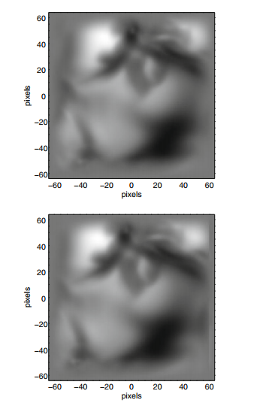
Figure 3.1: Pair of simulated 128 × 128 pixel solar images used for cross-correlation [1].

A Shack–Hartmann wavefront sensor divides the incoming wavefront into several sub-apertures using a lenslet array. Each lenslet forms an image, and the displacement of this image from its reference position provides information about the local wavefront slope [4]. In solar systems the sub-aperture images are typically about 32 × 32 pixels, as illustrated in Figure 3.2 [1].

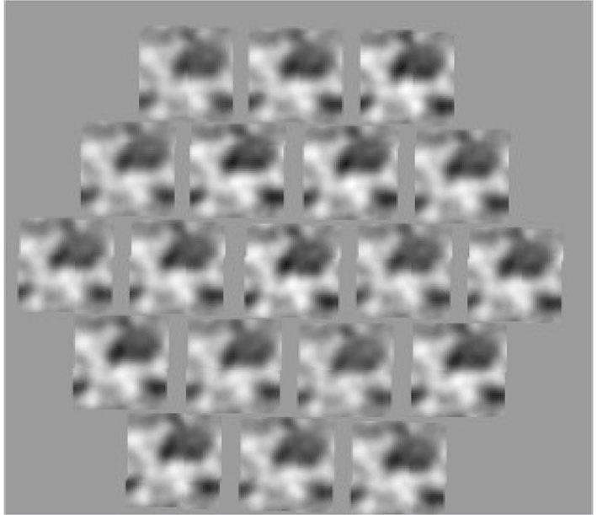
Figure 3.2: Simulated Shack–Hartmann sensor image with 19 sub-aperture images of a solar feature [1].

For extended solar structures, cross-correlation can be used to determine the image displacement. For a reference image I_{r}(x, y) and a current image I_{c}(x, y), the two-dimensional correlation can be expressed as

C(x, y) = Σ_{m} Σ_{n} I_{r}(m, n) · I_{c}(m + x, n + y) (3.1)

The position of the maximum correlation value gives the relative displacement between the two images [1], [4].

Direct spatial-domain correlation requires a very large number of multiply-accumulate operations, of the order of N⁴ for an N × N image. Fourier-domain correlation reduces this to the order of N² log N by using the FFT and is therefore more suitable for hardware implementation. By the Fourier shift theorem, if the current image is shifted by a vector a relative to the reference image, their Fourier transforms are related by
F_{c}(f) = F_{r}(f) · exp[ j2π f · a ] (3.2)
The shift can therefore be identified as the location of the peak of the normalized correlation

C(x, y) = F⁻¹[ F_{c}(u, v) F_{r}*(u, v) / | F_{c}(u, v) F_{r}*(u, v) | ] (3.3)

where F_{c} and F_{r} are the Fourier transforms of the two images and * represents complex conjugation. For a pure shift, the normalized product reduces to exp[ j2π f · a ], whose inverse transform is a delta function located at (a_{x}, a_{y}) [1].

The complete processing sequence consists of 2D FFT, complex multiplication, 2D inverse FFT and FFT shift. The maximum value in the resulting correlation matrix represents the image displacement.

This normalized approach is known as phase correlation and was introduced by Kuglin and Hines [8]. Compared with unnormalized spatial-domain correlation, it produces a sharp, well-localized peak and is less sensitive to illumination differences between the two images.

- SOLARACCEL FPGA ARCHITECTURE

SolarAccel implements the Fourier-domain cross-correlation operation using FPGA hardware. The implementation was developed in Verilog using the Xilinx Vivado tool and tested on a Xilinx Zynq UltraScale+ MPSoC on the ZCU104 evaluation platform at a clock frequency of 100 MHz [1], [13].

Two image sizes, 128 × 128 and 32 × 32 pixels, were considered, as these are the typical sizes used for cross-correlation in solar adaptive optics. The 2D FFT is implemented as two consecutive 1D FFT operations along the rows, with a transpose operation between them. The FFT IP block uses the pipelined streaming I/O architecture with a transform length of 128, since each row of the image contains 128 elements, and a 4-multiplier complex multiplier with butterfly arithmetic [1].

Four architectures were investigated. Design 1 used a serial architecture with the image data in single-precision floating-point format. Design 2 pipelined the same architecture, except for the transpose operation, which improved latency and reduced hardware usage. Design 3 switched to a 16-bit fixed-point representation of the image data to reduce hardware requirements further. Design 4 introduced parallel computation [1].

In the final architecture, the 128 × 128 image was divided into four 128 × 32 sections stored in separate block ROMs. The FFT was performed on these sections simultaneously by four FFT engines, as shown in Figure 4.2, which reduced the FFT processing latency by approximately four times [1].

The overall processing flow, shown in Figure 4.1, is
2D FFT → Complex Multiplication → 2D IFFT → FFT Shift → Peak Search.
Block Memory Generator IP cores are used for image storage. In the 16-bit fixed-point designs the memory port width was 16 bits with 16384 locations, reduced to 4096 locations in the final design because each image matrix is split into four 128 × 32 parts. A 16-bit Multiplier IP performs the fixed-point multiplication, and the location of the peak of the resulting correlation matrix gives the shift between the two images [1].

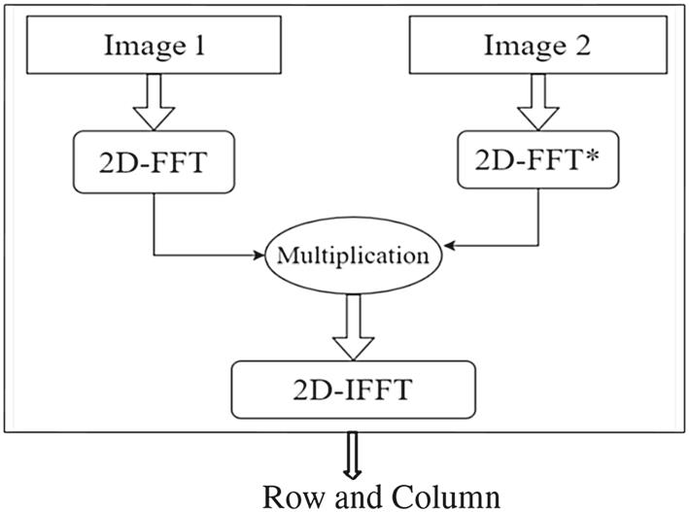
Figure 4.1: Signal flow of the SolarAccel cross-correlation [1].

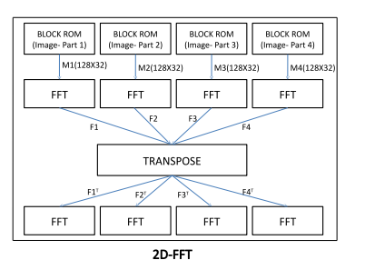
Figure 4.2: Parallel 2D FFT with the 128 × 128 image split into four 128 × 32 segments [1].

- IMPLEMENTATION AND RESULTS
The four architectures were evaluated in terms of latency and FPGA resource utilization. Table 5.1 gives the start and end times of each stage of the cross-correlation, obtained from simulation, for 128 × 128 images [1].

Table 5.1: Profiling of Designs 1–4 for 128 × 128 Images (time in μs) [1]

Stage | Design 1 | Design 2 | Design 3 | Design 4
1D_FFT | 4.99 – 168.83 | 4.99 – 168.83 | 3.45 – 167.29 | 3.45 – 44.41
2D_FFT | 338.99 – 502.84 | 173.97 – 337.81 | 167.50 – 331.34 | 47.93 – 88.89
Multiply | 515.92 – 679.76 | 174.19 – 338.03 | 167.53 – 333.37 | 47.96 – 88.92
1D_IFFT | 684.75 – 848.59 | 179.18 – 343.02 | 170.10 – 333.94 | 51.47 – 92.43
2D_IFFT | 1012.49 – 1176.33 | 348.07 – 511.91 | 339.98 – 503.82 | 95.99 – 136.95
FFT_Shift | 1341.16 – 1505.00 | 348.08 – 511.92 | 341.26 – 505.10 | 97.27 – 136.95

The final parallel architecture reduced the completion time of the last operation (FFT Shift) from 1505.00 μs in Design 1 to 136.95 μs in Design 4. Design 4 is therefore nearly 11 times faster than Design 1 and about 3.75 times faster than Design 2, which completes at 511.92 μs [1].
For 32 × 32 images, the maximum latency of the final design was approximately 13.4 μs. The shifts estimated on the FPGA were consistent with the MATLAB implementation for all data sets, except for an occasional error of ±1 pixel for large shift values, which is within the acceptable limit for this application [1].
The reduction in latency through parallel processing increases FPGA resource utilization, as shown in Table 5.2.

Table 5.2: Hardware Resource Utilization for 128 × 128 Images [1]
Resource | Available | Design 2 (%) | Design 3 (%) | Design 4 (%)
LUT | 230400 | 10.34 | 5.96 | 110.28
LUTRAM | 101760 | 7.47 | 3.51 | 175.04
FF | 460800 | 7.96 | 4.36 | 19.11
BRAM | 312 | 39.10 | 24.68 | 10.26
DSP | 1728 | 9.03 | 5.56 | 23.15
IO | 360 | 18.06 | 18.06 | 18.06
BUFG | 544 | 2.02 | 1.47 | 1.84
The number of LUTs increased by nearly 13 times in Design 4 compared with Design 3, and many Block RAMs were converted into LUT RAMs by the synthesis tool. LUT and LUTRAM utilization above 100% shows that the fully parallel 128 × 128 design exceeds the available logic of the device, illustrating the trade-off between processing speed and hardware resources [1].
For the smaller 32 × 32 image, the resource requirements were considerably lower, as shown in Table 5.3, making the implementation practical on the available FPGA device [1].

Table 5.3: Hardware Resource Utilization of the Final Design for 32 × 32 Images [1]
Resource | Used | Available | Utilization (%)
LUT | 44689 | 230400 | 19.40
LUTRAM | 15368 | 101760 | 15.10
FF | 47462 | 460800 | 10.30
BRAM | 16 | 312 | 5.13
DSP | 192 | 1728 | 11.11
IO | 65 | 360 | 18.06
BUFG | 10 | 544 | 1.84

Table 5.4: Comparison with Existing FPGA Implementations [1]
Implementation | Operation | Image Size | Clock (MHz) | Latency (μs)
Li and Wyrwicz [6] | 2D FFT | 128 × 128 | 80 | 310
SolarAccel [1] | 2D FFT | 128 × 128 | 100 | 88.8
SolarAccel [1] | 2D FFT | 32 × 32 | 100 | 7.96
Haji Rassouliha et al. [5] | Cross-correlation | 32 × 32 with 256 × 32 | 250 | 28.6
SolarAccel [1] | Cross-correlation | 128 × 128 | 100 | 136.95
SolarAccel [1] | Cross-correlation | 32 × 32 | 100 | 13.43
As shown in Table 5.4, SolarAccel performs the 2D FFT on a 128 × 128 image about 3.5 times faster than the design of Li and Wyrwicz [6], and completes the full 32 × 32 cross-correlation in less than half the time reported by Haji Rassouliha et al. [5], despite operating at a lower clock frequency. An exact comparison is not possible because of differences in clock frequency, FPGA device, number of processing elements and degree of parallelism [1].

- APPLICATIONS AND FUTURE SCOPE
The main application of the architecture is real-time image correlation in solar adaptive optics. The measured image displacement can be used to estimate wavefront tilt and generate the corresponding correction [1], [4].

For a large solar telescope such as NLST, about 450 two-dimensional cross-correlations must be computed every millisecond. If performed sequentially, this would take about 6 ms, much longer than the expected single-frame exposure time of about 1 ms [1].

Parallel correlation blocks can be replicated to process multiple sub-apertures simultaneously. The SolarAccel study estimates that replicating approximately 50 correlation blocks would allow all 450 correlations to be computed in about 130 μs, which corresponds to the unavoidable one-frame delay between wavefront sensing and correction [1].

Further development can include capturing the image data in real time from a high-speed camera, transferring it to the FPGA through an interface such as PCIe, buffering it in the on-board DDR memory, and integrating the correlation blocks with wavefront reconstruction and deformable-mirror control [1], [11]. The 50-block configuration for NLST has not yet been implemented and remains to be verified on actual hardware.

The main challenge is hardware resources. Even the 32 × 32 design uses about 19% of the LUTs on the ZCU104, so replicating 50 blocks would require several FPGA devices or a combination of sequential and parallel computation at a higher clock frequency [1]. Similar FPGA-based approaches are being explored for high-order wavefront control and for wide-field ground-layer adaptive optics in large solar telescopes, indicating a wider scope for this work [9], [10].
- CONCLUSION
Atmospheric turbulence limits the resolution of ground-based solar observations by distorting the incoming optical wavefront. Adaptive optics compensates for these distortions by measuring the wavefront and applying an appropriate correction.

In solar adaptive optics, cross-correlation provides a suitable method for determining the displacement of extended solar structures obtained from Shack–Hartmann wavefront sensors.

SolarAccel implements two-dimensional Fourier-domain cross-correlation using FFT, complex multiplication, IFFT and FFT shift operations. Four architectures were developed, with improvements obtained through pipelining, fixed-point representation and parallel processing [1].

The final architecture achieved a maximum latency of approximately 137 μs for 128 × 128 images and 13.4 μs for 32 × 32 images, nearly 11 times faster than the initial serial design and comparable with existing FPGA implementations [1]. The results demonstrate that FPGA parallelism can substantially reduce the processing latency, although higher parallelism requires increased hardware resources.
The architecture can be further developed by replicating correlation blocks and integrating high-speed image acquisition and wavefront-control hardware. Subject to validation on hardware, this makes it a suitable processing element for large-scale solar adaptive optics systems such as NLST.

REFERENCES
- S. Das, N. Rao, D. V. S. Phanindra, and S. Rengaswamy, "SolarAccel: FPGA accelerated 2D cross-correlation of digital images: Application to solar adaptive optics," J. Astrophys. Astr., vol. 45, no. 16, 2024, doi: 10.1007/s12036-024-10003-1.
- H. W. Babcock, "The possibility of compensating astronomical seeing," Publ. Astron. Soc. Pac., vol. 65, no. 386, pp. 229–236, 1953.
- D. L. Fried, "Statistics of a geometric representation of wavefront distortion," J. Opt. Soc. Am., vol. 55, no. 11, pp. 1427–1435, 1965.
- N. Gu et al., "Embedded solar adaptive optics telescope: achieving compact integration for high-efficiency solar observations," Opto-Electron. Adv., vol. 8, no. 5, p. 250025, 2025, doi: 10.29026/oea.2025.250025.
- A. Haji Rassouliha, T. P. Babarenda Gamage, M. D. Parker, et al., "FPGA implementation of 2D cross-correlation for real-time 3D tracking of deformable surfaces," in Proc. 28th Int. Conf. Image and Vision Computing New Zealand (IVCNZ), 2013, pp. 352–357.
- L. Li and A. M. Wyrwicz, "Parallel 2D FFT implementation on FPGA suitable for real-time MR image processing," Rev. Sci. Instrum., vol. 89, no. 9, p. 093706, 2018.
- F. Roddier, "The effects of atmospheric turbulence in optical astronomy," Progress in Optics, vol. 19, pp. 281–376, 1981.
- C. D. Kuglin and D. C. Hines, "The phase correlation image alignment method," in Proc. IEEE Int. Conf. Cybernetics and Society, 1975, pp. 163–165.
- M. S. Abo Rdan et al., "Accelerating high-order wavefront sensing and control algorithms with FPGAs," in Proc. SPIE 13627, Techniques and Instrumentation for Detection of Exoplanets XII, 136272D, 2025, doi: 10.1117/12.3064675.
- Y. Yang, L. Zhang, N. Yan, et al., "Ground-layer adaptive optics for the 2.5 m wide-field and high-resolution solar telescope," Res. Astron. Astrophys., vol. 24, no. 3, p. 035018, 2024.
- D. V. S. Phanindra et al., "FPGA-based fast data acquisition system for solar adaptive optics," Solar Physics Conference, Indian Institute of Astrophysics, Bengaluru, Jan. 2025.
- J. C. Wyant and K. Creath, "Basic wavefront aberration theory for optical metrology," in Applied Optics and Optical Engineering, vol. XI, Academic Press, 1992, pp. 2–53.
- AMD, "Zynq UltraScale+ MPSoC ZCU104 Evaluation Kit." [Online]. Available: https://www.amd.com/en/products/adaptive-socs-and-fpgas/evaluation-boards/zcu104.html
- Indian Institute of Astrophysics, "National Large Solar Telescope (NLST)." [Online]. Available: https://www.iiap.res.in/projects/nlst/

